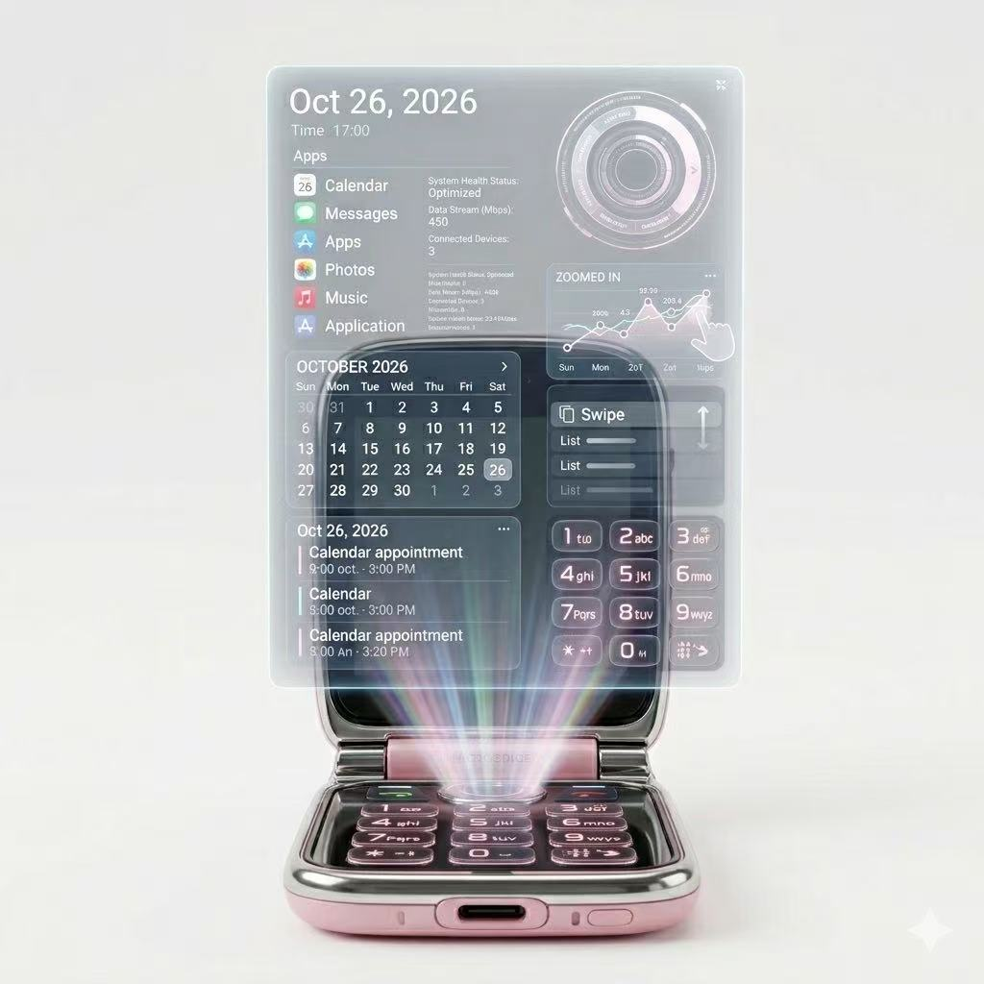
Front Holographic Interface Design
Prompt
A futuristic Y2K-inspired flip phone opened vertically, pastel pink and chrome body, glossy rounded edges, traditional keypad on the bottom half, large holographic interface projected upward from the phone screen, translucent floating UI panels showing calendar, apps, messages, music, swipe controls and system status, soft pink and blue light beams emitting from the hinge area, premium future smartphone concept, clean white studio background, semi-realistic product render, high-end technology aesthetic, detailed hologram projection, elegant and futuristic
Prompt说明
This prompt focuses on showing the phone’s main future interaction method: a holographic interface projected from a flip phone. The pastel pink, chrome finish, and keypad keep the Y2K identity, while the floating interface shows the future AI-phone experience.

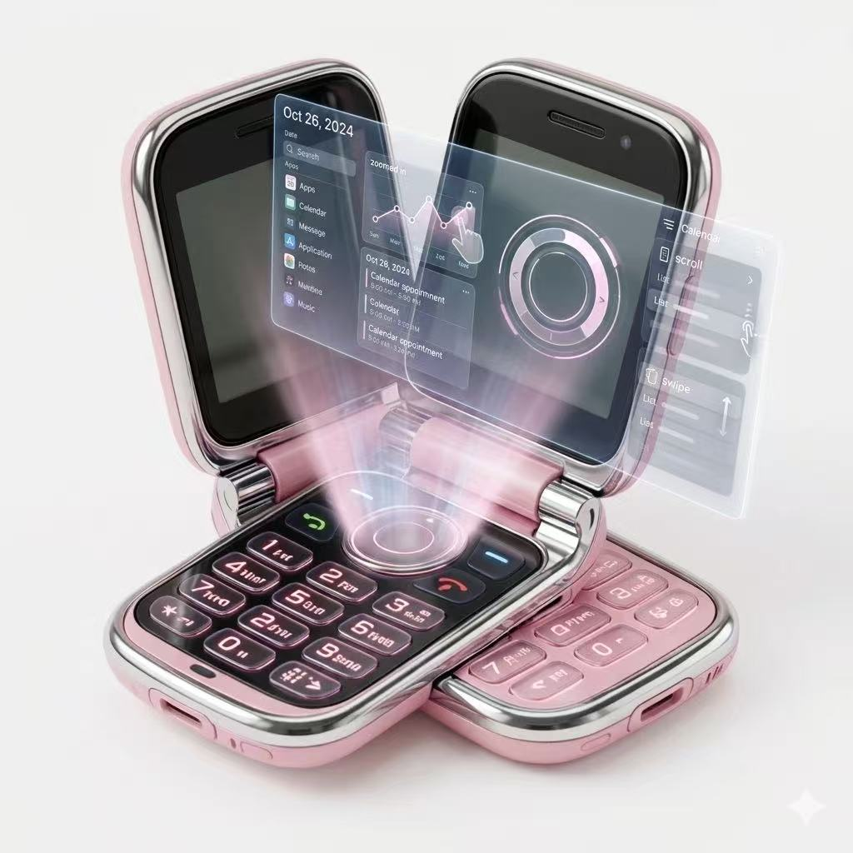
Dual-Screen Holographic Interaction View
Prompt
Two futuristic Y2K flip phones opened side by side, pastel pink glossy body with chrome edges, rounded clamshell design, physical keypad and black inner screens, holographic interface projected between the two phones, translucent floating UI panels with calendar, graph, apps and circular control system, soft pink light beams, premium concept phone design, futuristic interaction demonstration, white minimal background, semi-realistic 3D product render, high-end playful technology aesthetic, detailed reflections, elegant future phone presentation
Prompt说明
This prompt is used to show the phone’s holographic interaction system from an angled product perspective. The two-phone setup makes the hologram feel more dimensional and demonstrates how the interface can appear in space rather than staying inside the screen.
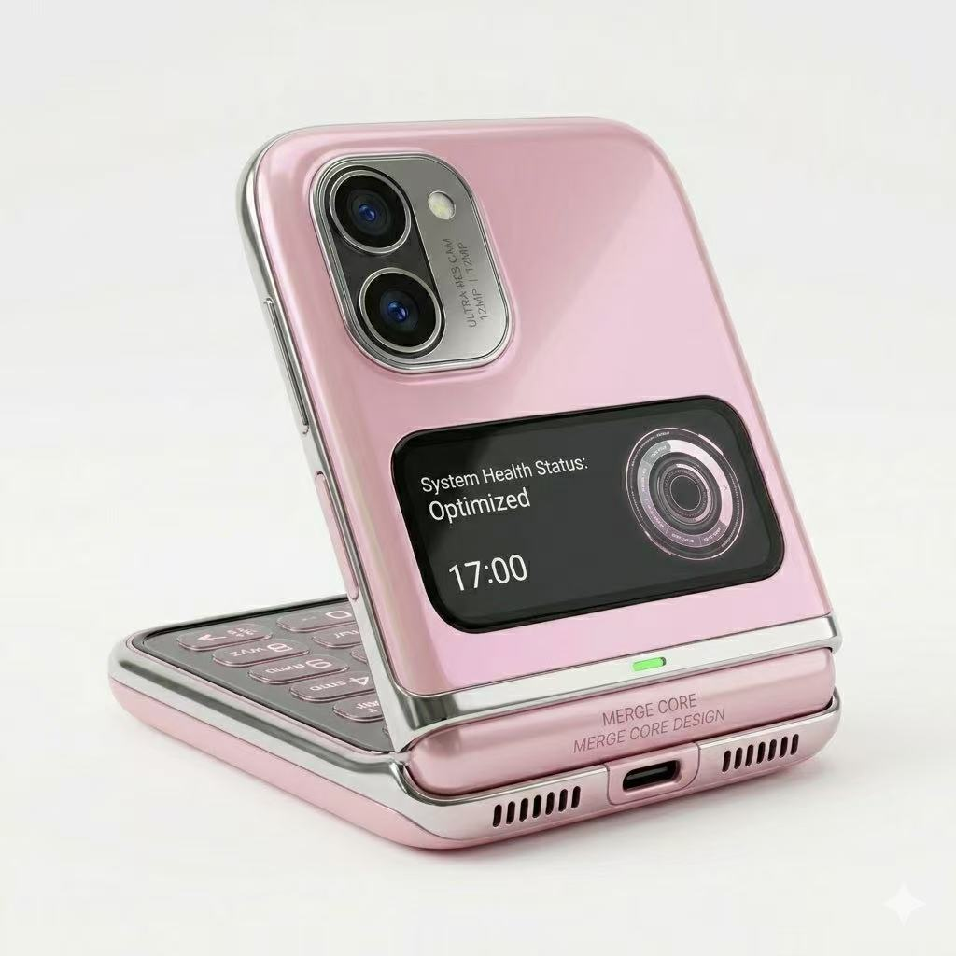
Rear Design / Back Panel Design
Prompt
Rear view of a futuristic Y2K-inspired flip phone, pastel pink glossy back panel, chrome edges, rounded clamshell body, compact premium design, dual spatial camera system on the upper back, small rectangular outer display showing system health status and time, subtle futuristic UI on outer screen, visible hinge structure, USB-C charging port and speaker grille at the bottom, high-end product render, clean white studio background, soft lighting, realistic reflections, stylish future smartphone exterior design
Prompt说明
This prompt describes the rear exterior design of the SIS HOLO phone. It highlights the camera system, outer display, hinge structure, and premium material finish. The back view helps show that the device is not only functional but also fashionable and refined.
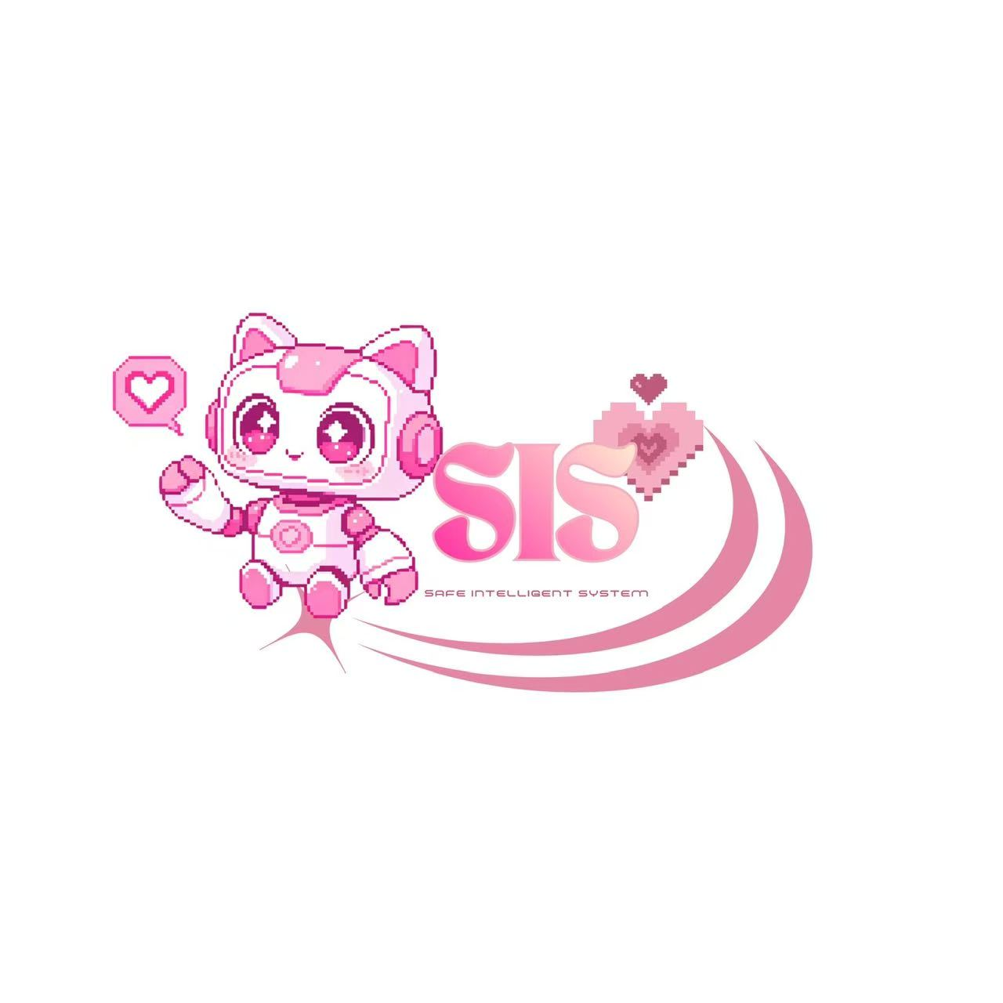
SIS Brand Identity Design
Prompt
Cute futuristic pixel art logo design for SIS, a pink and white robot cat AI assistant with headphones, big sparkling eyes, waving happily, small heart speech bubble, large text “SIS” in glossy pink Y2K font, small subtitle “Safe Intelligent System”, soft pink swoosh graphic, white clean background, kawaii technology mascot, friendly emotional AI companion, pixel art style, cute feminine futuristic branding, playful and supportive mood
Prompt说明
This prompt is for the SIS brand identity. The robot cat mascot makes the AI assistant feel cute, safe, and approachable. The pink Y2K logo style supports the phone’s emotional and friendly design direction.

Prompt
Cute pink and white robot cat AI assistant mascot, pixel art style, front-facing character, big sparkling eyes, cat ears, pink headphones, small heart speech bubble, waving hand, friendly and supportive expression, soft pastel pink color palette, kawaii futuristic design, emotional AI companion for a future smartphone, clean white background, simple icon composition, high-quality pixel art, playful and comforting mood
Prompt说明
This prompt focuses only on the AI assistant character. The mascot represents the emotional intelligence of SIS, acting like a friendly companion that can answer questions, provide support, and interact with users through the phone’s holographic interface.
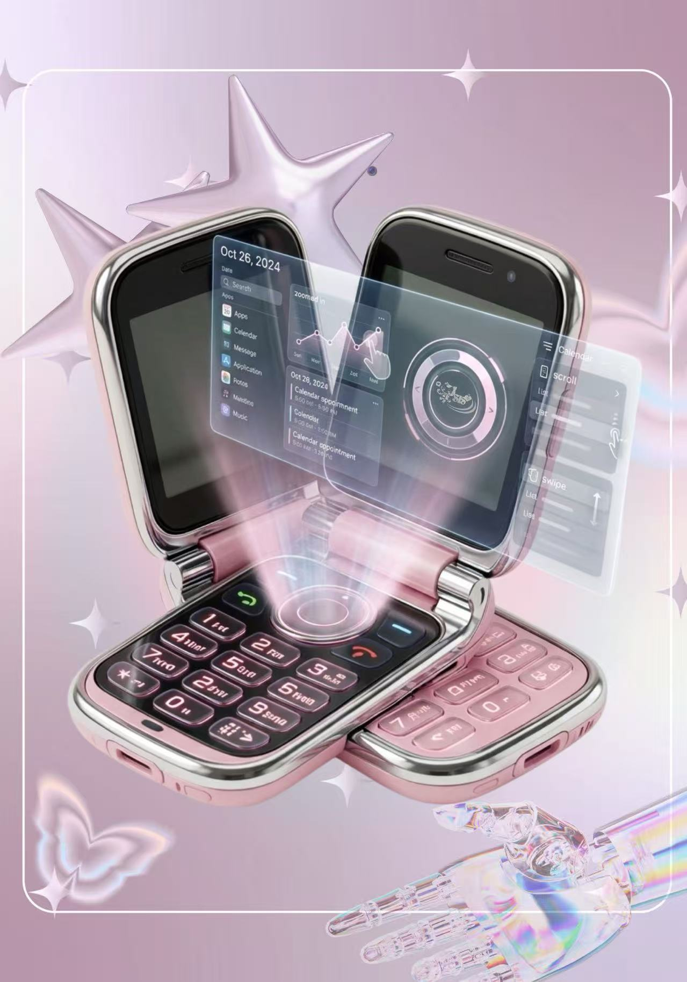
SIS HOLO Product Poster
Prompt
A Y2K futuristic product poster featuring a pastel pink flip phone with chrome edges, opened in a dramatic product display, holographic interface projected from the phone hinge area, floating translucent UI panels, soft pink light beams, glossy high-tech materials, cute dreamy background with pastel purple gradient, white rounded border frame, metallic star shapes, sparkles, butterfly decoration, transparent robotic hand at the bottom, feminine future technology aesthetic, stylish magazine poster layout, high-end Y2K sci-fi product advertisement, semi-realistic render, soft lighting, detailed reflections
Prompt说明
This prompt is designed to create a Y2K-style product poster for the SIS HOLO Phone. The pastel purple background, sparkles, metallic stars, butterfly, and transparent robotic hand strengthen the futuristic fashion identity of the phone. The holographic interface is placed at the center to show the main innovation: the phone does not only display information on a screen, but projects a floating interface into physical space.
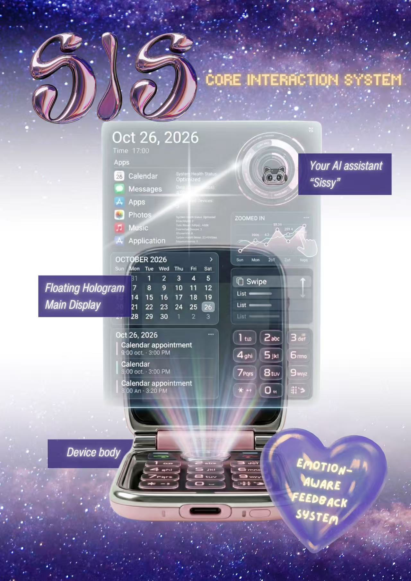
Core Interaction System Board
Prompt
Futuristic Y2K concept design board for SIS HOLO Phone, front view of a pastel pink flip phone projecting a large translucent holographic interface, chrome edges, glowing keypad, soft pink hologram beam, galaxy star background, large glossy metallic SIS logo at the top, pixel-style yellow title text “Core Interaction System”, purple label boxes with white italic text, thin annotation lines pointing to features, labels including Floating Hologram Main Display, Your AI assistant “Sissy”, Device body, Emotion-Aware Feedback System, dreamy purple heart sticker, high-end futuristic presentation board, Y2K magazine aesthetic, clean but playful layout
Prompt说明
This prompt is for a feature explanation board. It combines the product image with labels to explain the key interaction system: the floating hologram display, the AI assistant, the device body, and the emotion-aware feedback system. The galaxy background and metallic SIS logo make the page feel more branded and visually memorable.
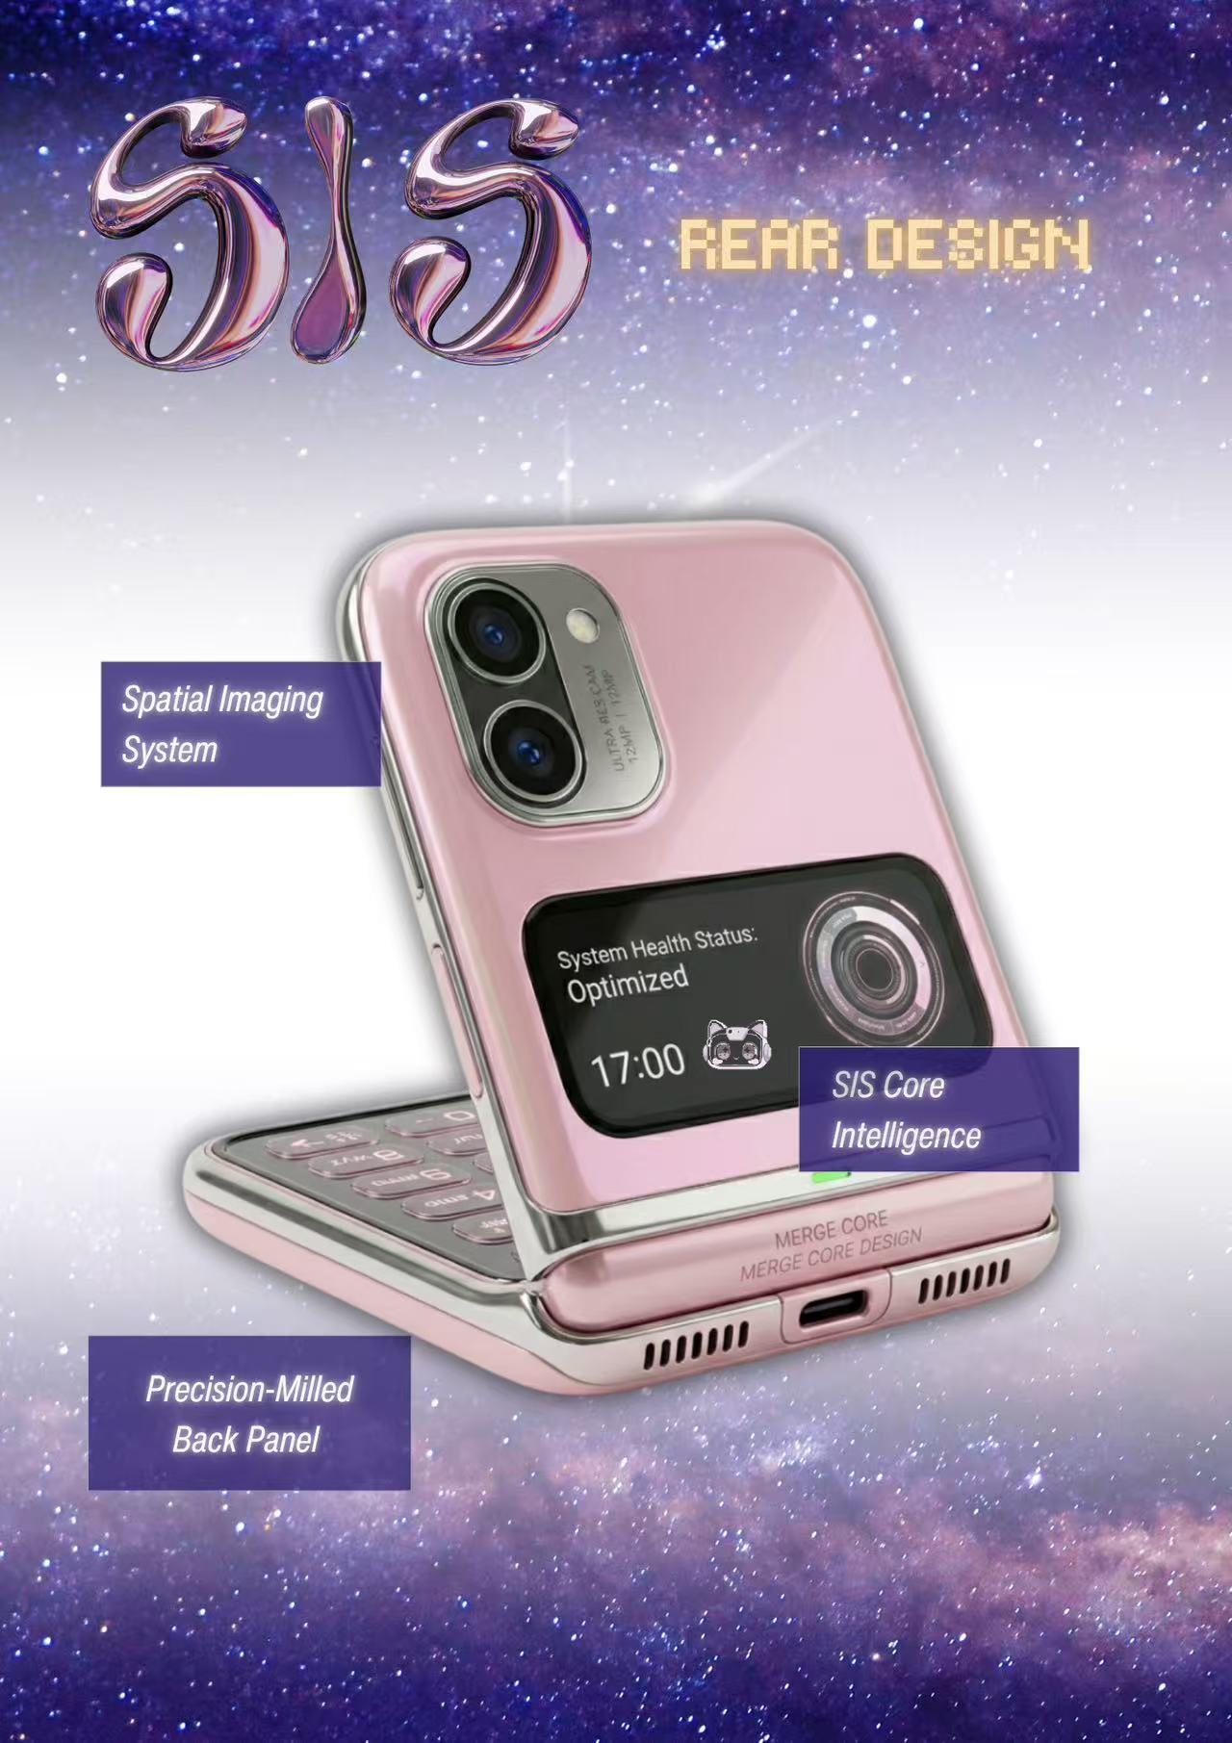
Rear Design
Prompt
Futuristic Y2K product design board showing the rear design of SIS HOLO Phone, pastel pink glossy flip phone opened from the back angle, chrome edges, rounded clamshell body, dual spatial camera system on the upper back, small outer display showing system health status and time, subtle SIS AI mascot icon on the outer screen, visible hinge structure, USB-C port and speaker grille at the bottom, galaxy star background, large glossy metallic SIS logo at the top, pixel-style yellow title text “Rear Design”, purple annotation label boxes with white italic text, thin lines pointing to Spatial Imaging System, SIS Core Intelligence, Precision-Milled Back Panel, high-end futuristic concept presentation, clean Y2K sci-fi aesthetic
Prompt说明
This prompt focuses on the rear exterior design of the phone. It highlights the back panel, camera system, outer display, hinge, and SIS Core Intelligence. Instead of using basic labels like “camera” or “screen,” the prompt uses more premium design language such as “Spatial Imaging System” and “Precision-Milled Back Panel” to make the concept feel more professional.

1. 前方全息界面设计
Front Holographic Interface Design
Prompt 中文翻译
一部未来感 Y2K 风格翻盖手机，垂直打开状态，机身为粉色与银色镀铬材质，表面光滑且边缘圆润。下半部分保留传统数字键盘，上方从手机屏幕中投射出大型全息界面。半透明悬浮 UI 面板显示日历、应用、信息、音乐、滑动控制和系统状态。柔和的粉色与蓝色光束从转轴区域发出，整体呈现高端未来智能手机概念。背景为干净的白色摄影棚风格，半写实产品渲染，高科技美学，细节丰富的全息投影，优雅且具有未来感。
Prompt 说明中文翻译
这个 Prompt 主要用于展示手机未来的核心交互方式：从翻盖手机中投射出的全息界面。粉色机身、银色镀铬材质和传统键盘保留了 Y2K 风格，而悬浮界面则展示了未来 AI 手机的交互体验。

2. 双屏全息交互视角
Dual-Screen Holographic Interaction View
Prompt 中文翻译
两部未来感 Y2K 翻盖手机并排打开，机身为粉色光泽材质，搭配银色镀铬边框，圆润的翻盖结构设计，带有实体键盘和黑色内屏。两部手机之间投射出全息界面，半透明悬浮 UI 面板包含日历、图表、应用和圆形控制系统。柔和粉色光束营造出未来交互演示效果。整体为高端概念手机设计，白色极简背景，半写实 3D 产品渲染，具有高级、趣味和未来科技感，反射细节丰富，呈现优雅的未来手机展示效果。
Prompt 说明中文翻译
这个 Prompt 用于从倾斜的产品视角展示手机的全息交互系统。双手机的构图让全息界面更具空间层次感，也表现出界面可以出现在现实空间中，而不是只停留在手机屏幕内部。

3. 背面设计 / 背板设计
Rear Design / Back Panel Design
Prompt 中文翻译
一部未来感 Y2K 风格翻盖手机的背面视角，粉色光泽背板，银色镀铬边缘，圆润的翻盖机身，整体紧凑且具有高级感。上方背部配有双空间影像系统，背面有小型矩形外屏，显示系统健康状态和时间。外屏带有轻微未来感 UI，转轴结构清晰可见，底部有 USB-C 充电接口和扬声器开孔。整体为高端产品渲染，白色干净摄影棚背景，柔和灯光，真实反射效果，展现时尚的未来智能手机外观设计。
Prompt 说明中文翻译
这个 Prompt 描述了 SIS HOLO 手机的背面外观设计。它重点展示了摄像系统、外屏、转轴结构和高级材质质感。背面视角可以说明这部手机不仅具有功能性，同时也具有时尚感和精致感。

4. SIS 品牌视觉设计
SIS Brand Identity Design
Prompt 中文翻译
为 SIS 设计一个可爱的未来感像素艺术 Logo：一个粉色与白色的机器猫 AI 助手，戴着耳机，拥有闪亮的大眼睛，开心地挥手，旁边有小爱心对话气泡。画面包含大号粉色光泽 Y2K 字体“SIS”，下方有小字副标题“Safe Intelligent System”，搭配柔和粉色流线图形，白色干净背景。整体为可爱科技吉祥物风格，友好、具有情感陪伴感的 AI 助手，像素艺术风格，女性化未来品牌视觉，氛围活泼且具有支持感。
Prompt 说明中文翻译
这个 Prompt 用于设计 SIS 的品牌视觉。机器猫吉祥物让 AI 助手显得可爱、安全且容易接近。粉色 Y2K 风格 Logo 支持了手机温暖、情感化和友好的设计方向。

5. SIS AI 助手吉祥物
SIS AI Assistant Mascot
Prompt 中文翻译
一个可爱的粉白色机器猫 AI 助手吉祥物，像素艺术风格，正面角色造型，拥有闪亮的大眼睛、猫耳朵、粉色耳机、小爱心对话气泡，并挥手示意。表情友好且具有支持感，使用柔和的粉色配色，可爱未来感设计。它是未来智能手机中的情感 AI 陪伴角色，白色干净背景，简单图标构图，高质量像素艺术，整体氛围活泼、温暖且令人安心。
Prompt 说明中文翻译
这个 Prompt 只聚焦于 AI 助手角色本身。这个吉祥物代表 SIS 的情感智能，它像一个友好的陪伴者，可以回答问题、提供支持，并通过手机的全息界面与用户互动。

6. SIS HOLO 产品海报
SIS HOLO Product Poster
Prompt 中文翻译
一张 Y2K 未来感产品海报，主角是一部粉色翻盖手机，搭配银色镀铬边缘，手机以戏剧化的产品展示方式打开。全息界面从手机转轴区域投射出来，悬浮着半透明 UI 面板，并伴随柔和粉色光束。手机材质具有光泽和高科技质感。背景为可爱梦幻的粉紫色渐变，带有白色圆角边框、金属星星、闪光装饰、蝴蝶元素，以及底部的透明机械手。整体呈现女性化未来科技美学、时尚杂志海报布局、高端 Y2K 科幻产品广告效果，半写实渲染，柔和灯光，反射细节丰富。
Prompt 说明中文翻译
这个 Prompt 用于生成 SIS HOLO Phone 的 Y2K 风格产品海报。粉紫色背景、闪光、金属星星、蝴蝶和透明机械手强化了手机的未来时尚属性。全息界面位于画面中心，突出核心创新：这部手机不仅在屏幕上显示信息，还能将界面投射到现实空间中。

7. 核心交互系统说明板
Core Interaction System Board
Prompt 中文翻译
一张 SIS HOLO Phone 的未来感 Y2K 概念设计说明板，正面展示一部粉色翻盖手机，手机投射出大型半透明全息界面。机身带有银色镀铬边缘、发光键盘和柔和粉色全息光束。背景为星空银河，大号金属光泽 SIS Logo 位于顶部，并使用像素风黄色标题文字“Core Interaction System”。页面包含紫色标签框和白色斜体文字，通过细线标注功能区域。标签包括：Floating Hologram Main Display、Your AI assistant “Sissy”、Device body、Emotion-Aware Feedback System。画面还加入梦幻紫色爱心贴纸，整体为高端未来感展示板，Y2K 杂志美学，布局干净但具有趣味性。
Prompt 说明中文翻译
这个 Prompt 用于生成一个功能说明板。它将产品图片和文字标签结合起来，解释手机的核心交互系统，包括悬浮全息主显示界面、AI 助手、设备机身和情绪感知反馈系统。银河背景和金属 SIS Logo 让页面更具品牌感，也更容易被记住。

8. 背面设计说明板
Rear Design
Prompt 中文翻译
一张未来感 Y2K 产品设计说明板，展示 SIS HOLO Phone 的背面设计。粉色光泽翻盖手机以背面角度打开，银色镀铬边缘，圆润翻盖机身。上方背部有双空间影像系统，小型外屏显示系统健康状态和时间，外屏上还有轻微的 SIS AI 吉祥物图标。转轴结构清晰可见，底部有 USB-C 接口和扬声器开孔。背景为银河星空，大号金属光泽 SIS Logo 位于顶部，并使用像素风黄色标题文字“Rear Design”。页面包含紫色注释标签框和白色斜体文字，细线指向 Spatial Imaging System、SIS Core Intelligence 和 Precision-Milled Back Panel。整体为高端未来概念展示板，干净的 Y2K 科幻美学。
Prompt 说明中文翻译
这个 Prompt 聚焦于手机的背面外观设计。它突出展示了背板、摄像系统、外屏、转轴结构和 SIS Core Intelligence。相比使用“camera”或“screen”这类基础标签，Prompt 使用了更高级的产品设计语言，例如“Spatial Imaging System”和“Precision-Milled Back Panel”，让整个概念看起来更加专业。

